**What I’ve learned (I): Cognitive Science Behind the Creation and Maintenance of Memory**

The process of creation and maintenance of memory can be explained by the following schematic. Going from the left to the right, we capture a ton of inputs from our surroundings in the form of feeling, light or sound which are passed into a short-term filtering compartment that we call *Sensory Memory*. The orange wave below it signifies seeping out of information that the brain does not deem necessary. Then the remaining information gets passed into the *Working Memory* compartment. The Green arrow on *Working Memory* going into itself, symbolizes the fact that there is a limit to what one can think at a time, in order for information to be maintained, we need to keep revisiting them. The memory goes into the third compartment, *Long-term Memory*, where certain amount of that memory gets stored and reinforced over time. The good news about is that the limit for *Long-term Memory* is not yet known to us, there are things that stay with us forever and there are memories that stay with us for years. The green arrow leading from *Long-term Memory* to *Working Memory* suggests that for immediate memory to work perfectly, we often need to pull information from *Long-term Memory* to function properly. The orange lines through all the compartments symbolize that we lose memory at every stage of the memory.

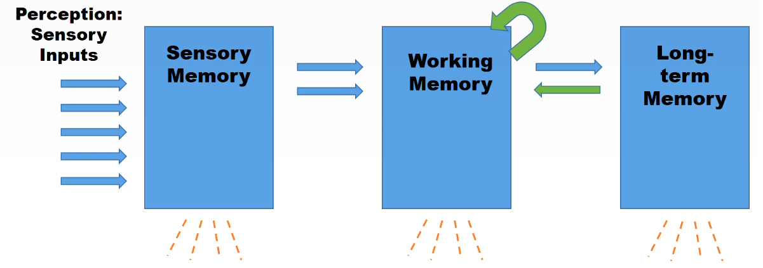  
**Figure 1**: Schematic for Information Processing Model

**What I’ve learned (II): Jigsaw Classroom: Three Principles of Learning**

Majority of this lesson was learnt from a very productive and insightful Jigsaw class. While it was an excitingly new way to learn, the format allows one to learn the course from multiple perspective, which in my opinion gives another layer of depth to the knowledge acquired. Three key principles were discussed by three assigned groups of students.

***Impact of Prior Knowledge:*** The principle behind it is that the prior knowledge of students can help or hinder learning based on circumstances. There are several points to touch on in relation to prior knowledge. It is essential to activate the prior knowledge for students. Students have a more efficient and fruitful learning process if they are pointed towards things they have learnt and known prior to the start of a course. However, it is important that the instructor does his/her research about the accuracy and extent of the students’ prior knowledge. What lands us into trouble is just asking the students, “What do you know?” instead of asking “How much of it do you know and how do you know of it?” Another essential point to consider is that the possibility of students having inappropriate prior knowledge. This makes them misunderstand the context of the knowledge and how they apply them to the current course. Lastly and probably the most fundamental thing to consider here, is if the prior knowledge for students have inaccuracy in them. A possible way to encounter that issue would be to test them of their knowledge with basic test at the beginning of the course.

***Knowledge Organization:*** This aspect of teaching concerns more on the structure of the course than the content of it. Since, the instructor is an “expert”, his/her concepts for the course is deeply connected with different aspects of subject. However, a student learning a new course will make relatively shallow connections due to lack of time and resources. While an instructors cannot change that extensively in the limited time allotted for a course, it is his/her responsibility to ensure the knowledge organization for the course enables students to get the most out of a course. Three aspects of knowledge need to be focused on. Knowledge needs to be organized in sync with the way the students are expected to perform in the discipline. In addition, while the teacher cannot expect same level of sophisticated and high level of connection of knowledge from students, they should focus of making the structure that best suits to perform the tasks required for the course. Lastly, instructors need to suggest organization schemes at the beginning of the course and monitor to ensure students are processing things in organized ways.

***Developing Mastery:*** Often when instructors deal with high level complicated information on a daily basis for research, tasks that seem simpler for them often are very convoluted for students, who are expected to have a different starting point. There are three aspects that need to be looked at, students need (a) to acquire certain component skills: Instructors need to decompose complex tasks to create pinpointed list of micro skills needed to accomplice a larger task and then develop exercises to test student’s performance for those smaller components, as well as, the whole bigger task; (b) to practice integrating the component skills: Once the students are well verse in terms of the component skills, it is essential for instructors to guide them to ensure they are able to integrate the learned components successfully; (c) to understand when and where to apply: The instructors would then need to provide ample set of diverse contexts to which the integrated pieces of knowledge can be applied.

**How I could personally apply the acquired knowledge about human learning in teaching students my discipline**

I could extract several pointers from the third week of the lessons. While how I use the lessons for my teaching will depend on what I am teaching. For the sake of this discussion, I choose a graduate level course in “Statistics in Transportation” and pick up several strategies that could be targeted specifically to this course.

***Prior Knowledge:*** Students are expected to have undergrad level statistical knowledge. To know the extent of their knowledge, I would need to create a survey that is in the form of a checklist that helps evaluate the past experience of the students (either in industry or in academia) and the extent of their prior knowledge in relation of the course I am teaching. Based the survey, I would need to make a proper intersection among the responses. At the same time, I would focus on students have less relevant prior knowledge and provide them reading/ practicing resources to catch up to the class requirements. Once that is done, I devise a short, ungraded “surprise” assignment to evaluate the accuracy and depth of the prior knowledge. Based on those responses, I would need to tweak the course materials to ensure I include enough introductory lessons that would be beneficial for majority of the class.

***Knowledge Organization:*** The course revolves around understanding statistical tools and how they can be used in solving real life transportation problems. By the end of the course, one would have learnt too many statistical concepts, which would make it really hard for students to understand how to connect different concepts to learn the subject in a way that is more insightful. To ensure the students are making the right connections between concepts, I would like the students to make their own concept maps at the different stages of the course, so that I could diagnose if they are having the right knowledge organization and fix student specific issues in that aspect.

***Developing Mastery:*** This being a very application based course, it is essential to expose students to as many real life problems as possible, both in form of in class solving (i.e. hand-holding), as well as, quizzes and assignments. The focus has to be on making sure I cover as varied set of real-life problems as possible. The gain from this is two-ways. Firstly, this ensures the students have enough exercises to understand how to how to integrate concepts and tie them to face a given problem. Secondly, the students will have an exhaustive set of exercises to use integrated knowledge to apply in real-life.

Comments:

Overall speaking, I think this assay is very good. The author summarized the contents in detail and provided the strategies that would help future teaching. The author described the memory process and introduced some concepts that covered the learning process. The author introduced the steps in the mastery process. And the author also commented the strategies using specific example, which is very helpful.

Comment: 1) The author can summarize the concepts, process, etc. a little bit more concisely. 2) The author may cite the sources of information used and add the reference to that.